**The process of making your kitchen cabinet**

1. You need to prepare your Kitchen dimension details like CAD file：

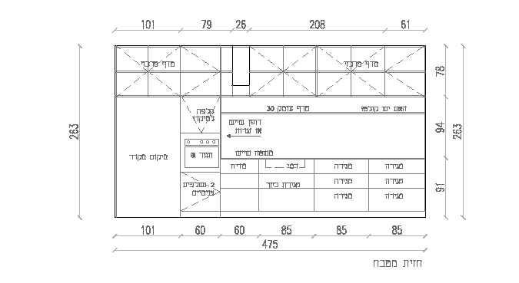

1. We will show you what kind of design you like,or you can show us what design you like ？

|  |  |  |
| --- | --- | --- |
|  |  |  |
|  |  |  |

1. Choose the material of the cabinet door and the colors and also the carcase marterials

|  |  |  |
| --- | --- | --- |
| MDF/HDF/Damp proof /fire proof | Plywood | Solid wood |
|  |  |  |

|  |  |  |
| --- | --- | --- |
| Glass door panel | Pvc door panel | Veneer |
|  |  |  |

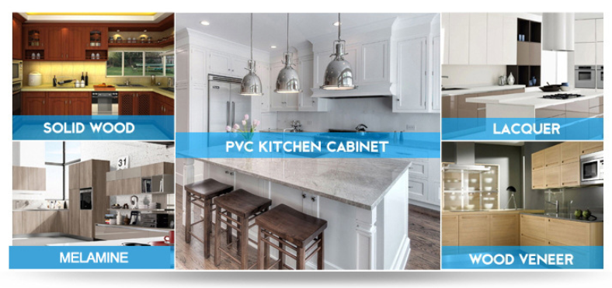

1. choose the counter top and parts and accessories

|  |  |  |
| --- | --- | --- |
| Quartz stone | Corian stone | Caesarstone |
|  |  |  |

|  |  |  |  |
| --- | --- | --- | --- |
| Aluminum rack | Spicy and knife rack | Up and down | Wood dish rack |
|  |  |  |  |
| Pantry basket | Pantry basket | Kitchen tool rack | SS dish rack |
|  |  |  |  |
| Lazy Susan | Up and down rack | Storage | Spicy Rack |
|  |  |  |  |

|  |  |  |  |
| --- | --- | --- | --- |
| Blum | Blum | Blum | Normal brand hinge |
|  |  |  |  |

1. Choose the build-in electric appliance

|  |  |  |  |
| --- | --- | --- | --- |
| Hood | Hood for Island | Build-in fridge | Dish washer |
|  |  |  |  |
| Laundry machine | Stove | Oven | Microwave |
|  |  |  |  |

1. Confrim the 2D and 3D （we will also provide CAD 2D dimension and 3D design according to your idea ,

and then you confirm it ）

|  |  |  |  |
| --- | --- | --- | --- |
| 2d | 3d | 2d | 3d |
|  |  |  |  |

1. Production and quality control .

We have professional factory to produce the nice and stable quality products.

|  |  |  |  |
| --- | --- | --- | --- |
| Factory producing line | Factory producing line | Factory view | Factory view |
|  |  |  |  |

1. Quality inspection .

This is the most important part of your whole order . we will assemble all the kitchen cabinet or wardrobe and check the size and other details like finishing ,painting ,surface ,ect ,before giving to you .

|  |  |  |  |
| --- | --- | --- | --- |
|  |  |  |  |
|  |  |  |  |

1. Package , this is also very important，we will have two option ;Flat-packing which can

save the space while shipping . 2nd is installed packing /fixed packing . we can assemble your kitchen cabinet here with safe packing ，this will be easy for you when you don’t need spend to much time on your installing .

Other important thing is : we will label/mark all the box with the kitchen cabinet number according to the 2D map .and that will be much easier for you to recognize which cabinet.

|  |  |  |  |
| --- | --- | --- | --- |
| Wood box packing while it is glass inside | Wooden packing like stone top or glass | Bubble paper and paper box | Install packing we will rape bubble paper and then paper box or wooden packing |
|  |  |  |  |
| Flat-packing | Label and mark | Plywood packing for fumigation | Container loading |
|  |  |  |  |

1. Shipping and arrange documents for custom . THE END